**HUMAN BIOLOGY UNIT 2**

**REPRODUCTION & PREGNANCY TEST**

NAME: _____________________________ DATE: __________

WEIGHTING: 5% MARK: ______ / 72 = ______ %

PLEASE DO NOT MARK THE MULTIPLE CHOICE SECTION

WRITE YOUR ANSWERS IN THE ANSWER BOOKLET

**MULTIPLE CHOICE SECTION**

Circle your selected answer on the answer sheet

1. During which stage of mitosis does DNA replication occur?
   1. Interphase
   2. Prophase
   3. Metaphase
   4. Anaphase
2. The S phase of the cell cycle represents
   1. the cell at rest
   2. DNA replication
   3. Mitosis
   4. None of the above
3. Following meiosis, a germ cell may have produced four sperm cells. The total number of chromosomes in the sperm cells will be:
   1. Four times that of the germ cell
   2. Half that of the germ cell
   3. Twice the number in the original germ cell
   4. The same as in the original germ cell
4. Which of the following is the correct name for the process in which a cell splits into two smaller cells?
   1. Karyokinesis
   2. Metakinesis
   3. Cytokinesis
   4. Prokinesis
5. Following meiosis, a germ cell may have produced four sperm cells. The total number of chromosomes in the sperm cells will be:
   1. Four times that of the germ cell
   2. Half that of the germ cell
   3. Twice the number in the original germ cell
   4. The same as in the original germ cell
6. Which of the following correctly compares mitosis and meiosis in humans? Mitosis

a. involves the production of two identical cells, meiosis produces four different cells

b. requires two divisions, meiosis requires four divisions

c. is only for growth, meiosis is for reproduction

d. stops at adulthood, meiosis begins during puberty.

1. In which of the following ways are human sperm and ova similar?

a. They have approximately the same mass

b. About the same number of each is produced

c. They are both motile

d. They have the same number of chromosomes

1. The production of male sperm occurs best at:
   1. Normal body temperature, 37 °C
   2. Above normal body temperature
   3. Below normal body temperature
   4. Temperatures a few degrees above or below 37 °C

The following graph shows the development of a particular adult woman’s endometrium over the time shown. Use this graph to answer questions 7 and 8.

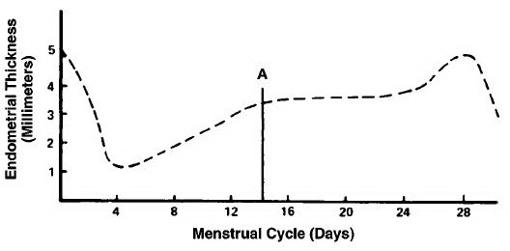

1. On which days shown on the graph did menstruation begin?
   1. day 4
   2. day 0
   3. day 25
   4. day 16
2. Ovulation from either one of her ovaries would probably have occurred around:
   1. day 24
   2. day 14
   3. day 0
   4. day 4
3. The follicle stimulating hormone (F.S.H.) stimulates the

a. development of the corpus luteum.

b. production of progesterone.

c. production and development of a mature oocyte, in the female and the production of sperm in the seminiferous tubules in the male.

d. vascularization of the endometrium, resulting in it becoming thickened.

1. Progesterone secretion decreases sharply near the end of the cycle because
   1. pregnancy occurs.
   2. ovulation occurs.
   3. a mature follicle develops.
   4. the corpus luteum degenerates
2. Which of the following are secondary sexual characteristics of the human female?
   * 1. Development of the ovaries
     2. Hairs growing around the genitalia
     3. Voice changes to a deeper one
     4. Broadening of the pelvic girdle
     5. Breast development

a. i and v only

b. ii and iv only

c. i, iii and v only

d. ii, iv and v only

1. Fertilisation usually occurs in the:
   1. ovary
   2. fallopian (uterine) tube
   3. uterus
   4. vagina
2. The region where the embryo is fixed to the mother is called the
   1. umbilical cord
   2. placenta
   3. amnion
   4. mesoderm
3. The developing offspring after 8 weeks of gestation is properly called:
   1. an infant
   2. an embryo
   3. a foetus
   4. a zygote
4. The embryo is surrounded by the amniotic cavity, filled with amniotic fluid. This fluid:

i. Acts as a shock absorber

ii. Provides a medium through which the exchange of materials takes place between the mother and embryo

iii. Helps to regulate a constant temperature

iv. Produces hormones for the developing embryo

1. i and iv only
2. ii and iii only
3. i and ii only
4. I and iii only
5. After conception, the main organs of a developing offspring are established by the end of the:
   1. third day
   2. second week
   3. ninth week
   4. fourth month
6. The developing offspring is most susceptible to the effects of alcohol during which stage of pregnancy?
   1. Just before birth
   2. In the first three months
   3. In the second three months
   4. In the last three months
7. The most acceptable reason why parents may wish to select the sex of their child is
   1. to avoid sex linked diseases
   2. to balance the family’s gender
   3. to provide the appropriate gender for possible future employment opportunities
   4. to assist with the requirements of the family’s future income
8. If a couple who have been trying unsuccessfully to have a baby wished to try IVF using the woman’s own ovum and the man’s sperm, which infertility problem do they most likely have?
   1. Failure of the sperm to mature
   2. Reduced levels of progesterone causing the endometrium to break down
   3. Insufficient room for the foetus in the uterus
   4. Blocked uterine tubes preventing the egg cell from travelling to the uterus
9. Seminal fluid

a. provides nutrition for the ovum.

b. causes contraction of the uterus.

c. neutralises the acidic nature of the vagina.

d. develops secondary sexual characteristics.

**Use the following diagram to answer question 23:**

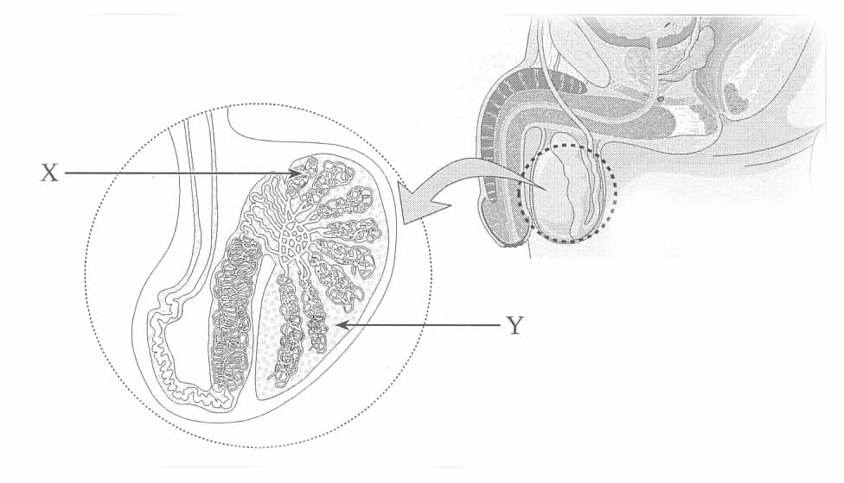

1. The function of the substance produced at **Y:**
2. fertilises the egg.
3. neutralises that acidity of the vagina.
4. provides sperm nourishment.
5. enhances muscular development.

**HUMAN BIOLOGY UNIT 2 REPRODUCTION TEST NAME: ___________________**

**MULTIPLE CHOICE ANSWER SECTION [20 marks]**

**1. a b c d 5. a b c d 9. a b c d 13. a b c d 17. a b c d**

**2. a b c d 6. a b c d 10. a b c d 14. a b c d 18. a b c d**

**3. a b c d 7. a b c d 11. a b c d 15. a b c d 19. a b c d**

**4. a b c d 8. a b c d 12. a b c d 16. a b c d 20. a b c d**

**SHORT ANSWER SECTION** **[42 MARKS]**

Write your answers in the spaces provided below

1. Immediately following fertilisation, the zygote begins to divide to form a solid ball of cells. As cell division continues, the cells arrange themselves into a hollow ball of cells as seen in the micrograph image below: **[TOTAL = 9 MARKS]**

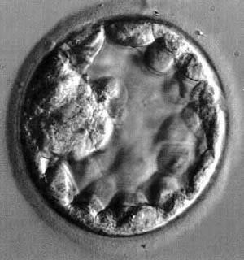

a. What is the name given to this hollow ball of cells? _______________________ [1 mark]

b. Which part of the hollow ball of cells contains the embryonic cells? ________________________________ [1 mark]

c. The extra-embryonic cells within the hollow ball of cells give rise to two membranes. What are the names and functions of these two membranes? [4 marks] ________________________________________________________________________________________________________________________________________________________________________________________________________________________________________________________________________________________________________________

d. After implantation, embryonic cells give rise to three primary germ layers, which will be differentiated into various cells and tissues. Name each primary germ layer and give an example of a cell or tissue that arises from each. [3 marks]

____________________________________________________________________________________________________________________________________________________________________________________________________________________________________

2. A stem cell is an undifferentiated cell that is capable of giving rise to indefinitely more cells of the same type, and from which other types of cells arise by differentiation depending on the cells potency. **[TOTAL = 6 MARKS]**

Complete the following table: [6 marks]

|  |  |  |
| --- | --- | --- |
| **Stem Cell**  **Potency** | **Can give rise to…** | **Example of where**  **stem cell can be found** |
| Totipotent |  |  |
| Pluripotent |  |  |
| Multipotent |  |  |

2. Label the diagram of the female reproductive system below: **[TOTAL = 4 MARKS]**

1. 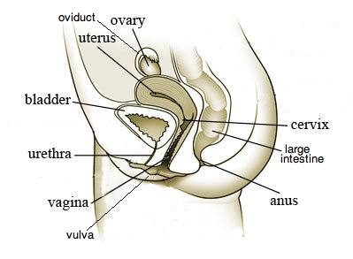________________________
2. ________________________
3. ________________________
4. ________________________
5. ________________________
6. ________________________
7. ________________________
8. ________________________

4. a. Describe the function of these male reproductive organs: **[TOTAL = 4 MARKS]**

i. Epididymis [1 mark]

________________________________________________________________________________________________________________________________________________________

ii. Vas deferens [1 mark]

________________________________________________________________________________________________________________________________________________________

Which four male reproductive glands contribute to the production of semen? [2 Marks]

________________________________________________________________________________________________________________________________________________________

5. Gametogenesis is the process that produces gametes in males and females. Spermatogenesis is the process that forms male gametes, known as spermatozoa.

Oogenesis is the process that forms female gametes, known as ova. **[TOTAL = 6 MARKS]**

a. How many chromosomes are found in spermatozoa? [1 mark] ____________________________________________________________________________

b. Why is it important that spermatozoa have this chromosome number? [1 mark] ________________________________________________________________________________________________________________________________________________________

c. Complete the table below, which outlines the differences between the processes of spermatogenesis and oogenesis? [3 marks]

|  |  |  |
| --- | --- | --- |
|  | **SPERMATOGENESIS** | **OOGENESIS** |
| Age of individual when the  process starts occurring |  |  |
| Number of gametes  produced for each cell that undergoes the process |  |  |
| Size of the products |  |  |

d. What is the advantage of producing one viable ovum and three polar bodies? [1 marks]

________________________________________________________________________________________________________________________________________________________

6. Examine the diagram below, which shows the events that occur inside the ovary during a normal ovarian cycle **[TOTAL = 9 MARKS]**

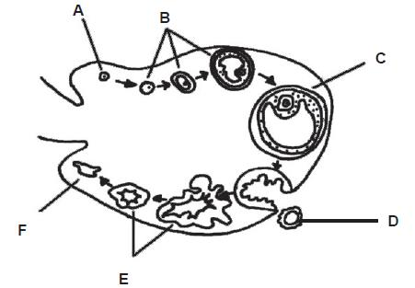

1. Name structure **A**. [1 mark] ___________________________________________________________________________
2. What is the name of the event shown at point **D**? [1 mark] __________________________________________________________________________
3. The **corpus albicans** is best represented by which structure? [1 mark] ___________________________________________________________________________
4. Name a hormone secreted by structure E and state its function. [2 marks] ___________________________________________________________________________ ____________________________________________________________________________ ___________________________________________________________________________
5. At approximately what day in the cycle would you expect to find structure **C**? [1 mark] __________________________________________________________________________
6. At what point in the cycle would you expect menstruation to occur? [1 mark] __________________________________________________________________________
7. After fertilisation, what day of embryonic development does implantation occur and into what tissue does the blastocyst attach? [2 marks] ____________________________________________________________________________ ____________________________________________________________________________

7. Answer the questions below **[TOTAL = 4 marks]**

a. List and explain **two** teratogens that can affect the development of an embryo and/or foetus?

[2 mark]

____________________________________________________________________________ ____________________________________________________________________________

____________________________________________________________________________ ____________________________________________________________________________

b. Babies born at 25 weeks have a very small chance of survival. State **one** main problem that affects the survival of premature babies. [1 mark]

____________________________________________________________________________ ____________________________________________________________________________

____________________________________________________________________________ ____________________________________________________________________________

c. What is **one** ethical issue dominating Australian society that an individual needs to consider when using assisted reproductive technology? [1 mark]

____________________________________________________________________________ ____________________________________________________________________________

____________________________________________________________________________ ____________________________________________________________________________

**EXTENDED ANSWER SECTION**  **[TOTAL = 10 MARKS]**

Note: You need to answer BOTH questions 13 and 14 in the space below

8. List five major changes that take place in a female during pregnancy and explain the reason for each change [5 marks]

9. List five foetal diagnostic techniques and explain how these techniques are able to monitor the health of a developing embryo and/or foetus? [5 marks]

____________________________________________________________________________

____________________________________________________________________________

____________________________________________________________________________

____________________________________________________________________________

____________________________________________________________________________

____________________________________________________________________________

____________________________________________________________________________

____________________________________________________________________________

____________________________________________________________________________

____________________________________________________________________________

____________________________________________________________________________

____________________________________________________________________________

____________________________________________________________________________

____________________________________________________________________________

____________________________________________________________________________

____________________________________________________________________________

____________________________________________________________________________

____________________________________________________________________________

____________________________________________________________________________

____________________________________________________________________________

____________________________________________________________________________

____________________________________________________________________________

____________________________________________________________________________

____________________________________________________________________________

____________________________________________________________________________

____________________________________________________________________________

____________________________________________________________________________

____________________________________________________________________________

____________________________________________________________________________

____________________________________________________________________________

____________________________________________________________________________

____________________________________________________________________________

____________________________________________________________________________

____________________________________________________________________________

____________________________________________________________________________

____________________________________________________________________________

____________________________________________________________________________

____________________________________________________________________________

____________________________________________________________________________

____________________________________________________________________________

____________________________________________________________________________

____________________________________________________________________________

____________________________________________________________________________

**END OF TEST**